* What is “list” in R?
  + List in R is a data structure which contains components of mixed data types like number, strings, vector, another list etc.

• How to create a list containing strings, numbers, vectors and a logical values in R?

* In R, we can create a list using `list` function. The code snippet below shows creation of a list containing strings, numbers, vectors and logical values.

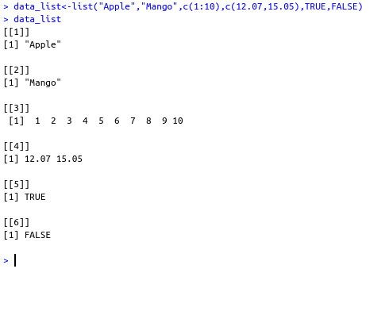

• How to name the list elements in R?

* We can name the list element while creating a list by assigning each element to a variable or we can name them after the list is created using `names()` function.

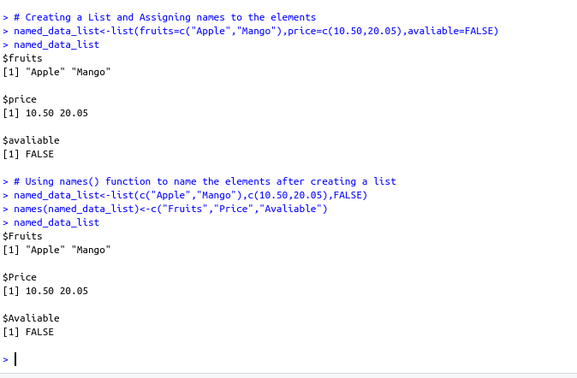

• How to assess list elements in R?

* Elements in a list can be accessed by using the index of the element and in the case of named list we can also use element name.

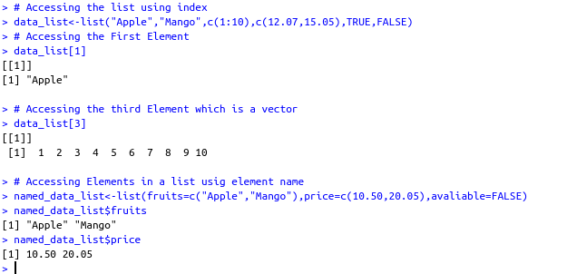

• How to manipulate list elements in R?

* We can add, delete and update the elements in a list.

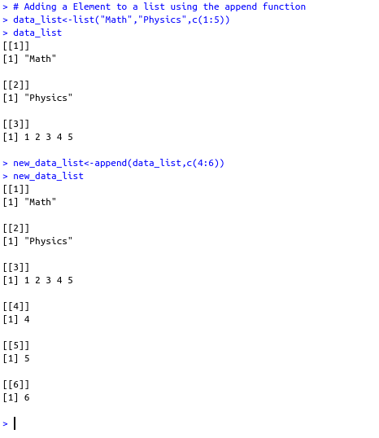

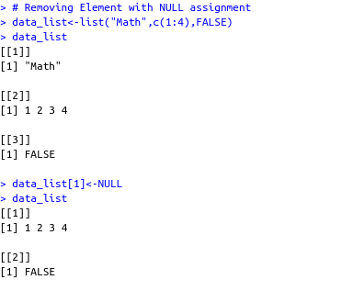

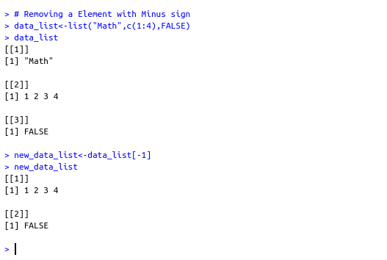

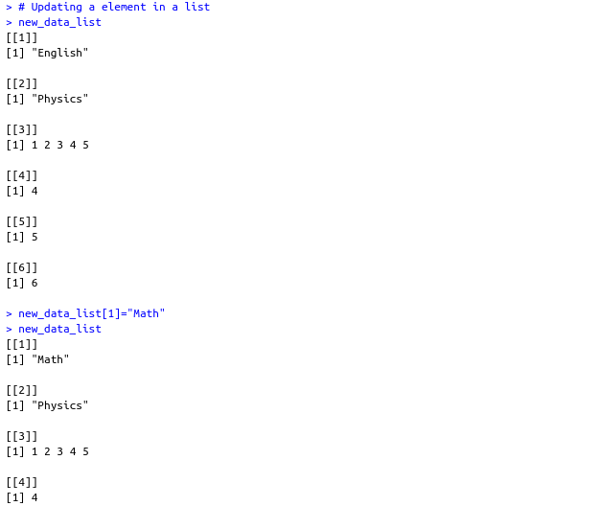

• How to convert list to vectors in R?

* To convert list into a vector we can use `unlist()` function.

